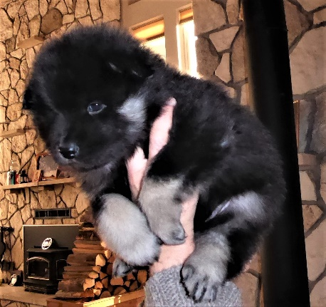
Application
Thank you for your interest in Big Sky’s Rocky Mountain Eurasiers! We are serious about placing our treasured gems correctly in their forever homes. Please fill out our questionnaire so that we may learn more about you and thus assist us … together with you…. in choosing the right match for you to give you the magical joy of an Eurasier in your life. The best way to fill out this application is to print it , then scan it back to your computer and email me a copy. bluebird@interbel.net
First Name: ________________________________________
Last Name: _________________________________________
Spouse/Significant Other Name (or write none): ______________________________________
Email Address: ___________________________________
Cell Phone:______________________________
Home Phone: ____________________________
Spouse/Significant Other Cell Phone: __________________________________
Address: ________________________________________________________
City: ____________________________________________
State/Province: ____________________________________
Zip/Postal Code: ____________________________________
Country: _____________________________________
HOME: Residence Type
House ____
Condo____
Apartment ____
Acreage____
Other ____
If you answered other, please explain: ____________________________________________________
___________________________________________________________________________________
Does your home have any of the following (please check all that apply)?
Fenced yard: ___
No Fenced yard: ___
Dog Door: ___
Dog run/kennel: ___
Dog crate: ___
Public park (near your home): ___
Dog Park (near your home): ___
Beach (near your home): ___
Field (near your home): ___
Wooded area (near your home): ___
Off-leash area (near your home): ___
WORK:
Occupation(s): ________________________________
Hours worked per day: _____
Do you work from home?: _____
Spouse/Significant Other Occupation(s): __________________________
Spouse/Significant Other hours worked per day: _____________
Does Spouse/Significant Other Work from home?: ____________
Would you, or your significant other be able to take your dog to work with you?: _______
FAMILY:
Marital/Family Status: ________________________________
Children? _________ If so, ages of: _____________________________________
Your Age: ________
Spouse/Significant Other Age: _________
Allergies?: ___________
Explain Allergies (if any): __________________________________________________
EXPERIENCE:
Will this be your first dog?: __Do you currently have any dogs?: ___If so, please list breed, ages, sex, spayed, neutered, intact:___________________________________________________________________________ ________________________________________________________________________________
Why do you want a dog? ______________________________________________
Do you prefer a male Eurasier pup, female Eurasier pup or either? _________________
Do you have a color preference (please explain) ? ____________________________________
Do you plan to spay or neuter your Eurasier? ___________
Do you plan to breed your Eurasier? ____________
Are you interested in :
Conformation/Show: _____
Obedience: _____
Agility: _____
Breeding: _____
Companionship: _____
Tracking: _____
Service Dog: _____
Therapy Dog: _____
OTHER INFORMATION:
Please describe the characteristics you would like in an ideal dog. Please be very detailed as this is very important to be sure you get the best fit for you and your family.___________________________________________________ ____________________________________________________________________________________
What kind of interests (hobbies) and activities do you and those in your household participate in?___________________ ____________________________________________________________________________________
Please describe how a Eurasier will fit into your family._____________________________________________ ____________________________________________________________________________________
How did you hear about the Eurasier breed? ____________________________________________________
Why are you interested in a Eurasier? _________________________________________________________
Where will your Eurasier live? Inside, Outside, freely moving between both via a dog door? __________________
Explain further (where your Eurasier will live) sleeping arrangements, when you are not home, etc._________________________________________________________________________________
How many hours of the day will the Eurasier be left without direct human physical contact? __________________
When left alone or without direct human physical contact, where will your Eurasier be kept? __________________
__________________________________________________________________________________
Outside of family members, who else might care for your Eurasier (e.g. neighbors, dog sitters, pet boarding etc.)?
___________________________________________________________________________________
Are you aware of the grooming requirements for a Eurasier? ___________
Will you be doing all the training yourself? ___If not, will you be working together with a trainer and your pup?____ Are you aware that Eurasiers need gentle, not harsh training methods?____ Please never put a prong, choke, or shock collar on your Eurasier, as they are a very sensitive breed.
Are you interested in a lifelong relationship with your breeder? _____________
It is recommended that exams for hips, elbows, patella luxation, thyroid, and eyes be given when the Eurasier reaches 2 years of age. Costs vary between $500-$1200 depending on location. Do you plan to proceed with this testing whether you breed or not? __________
Would you commit to sending photos and quick updates at least monthly until the pup is one year old, and then every 6-12 months after that for life? _________
If for any reason your family can no longer keep your Eurasier, one Condition of Sale is that you must first contact the breeder to discuss options about finding a new home for your Eurasier. We must be given the option of taking the Eurasier back. We are happy to work with you if you have a home. We do not want the Eurasier to be placed in a shelter - EVER!! Do you agree to this condition of sale? ______
Given the following situations, such as relocation, new baby in the family, newly acquired allergies, severe financial problems, divorce, separation, death of owner, etc… what will happen with your Eurasier?__________________
I do not ship my puppies, are you willing and able to pick up your Eurasier puppy in person? ____
How did you hear about me, or find my website? __________________________________________________
Any questions, comments, or concerns you may have please add below and thank you for sticking with us and filling out this application:

